6. The gods of this world

The gods of the education world, like all gods of this world, are dying, aren’t they? Carrying their mortal wounds they stumble about our schools and universities. Which gods? The gods we esteem like the god of developmental psychology who can’t help the boy in the front of my classroom. And that god of the senior school exam board who sorts students into graduates and failures, prophesying over lives. The god of the new literacy movement promises that illiteracy will plummet when we embrace the new methodology-we know in the wings its replacement is soon to be released promising the same utopian things for the planet. We should remember too, our cherished god of Christian schooling that sees faith quarantined into chapel and multi-faith Religious Studies classes - the majority of the school week is a baptized secular curriculum hardly different from other schools about us. Where are the cadres of Luthers, Mother Teresas, Wesleys and Romeros promised from such hallowed schools? Where is the transformed and enlightened society all these gods promise?

The reality is, as you well know, these gods are no more worthy of your ultimate trust that the people who created them, those wizards of Oz who hide behind the machinery of philosophy and institutions. Today we walk up the hallways and into our classes to serve YHWH, great and mighty, whose ways are just and true.

Revelation 15:3-4 "Great and marvelous are your deeds, Lord God Almighty. Just and true are your ways, King of the ages. Who will not fear you, O Lord, and bring glory to your name? For you alone are holy. All nations will come and worship before you.
Jeremiah 29:11
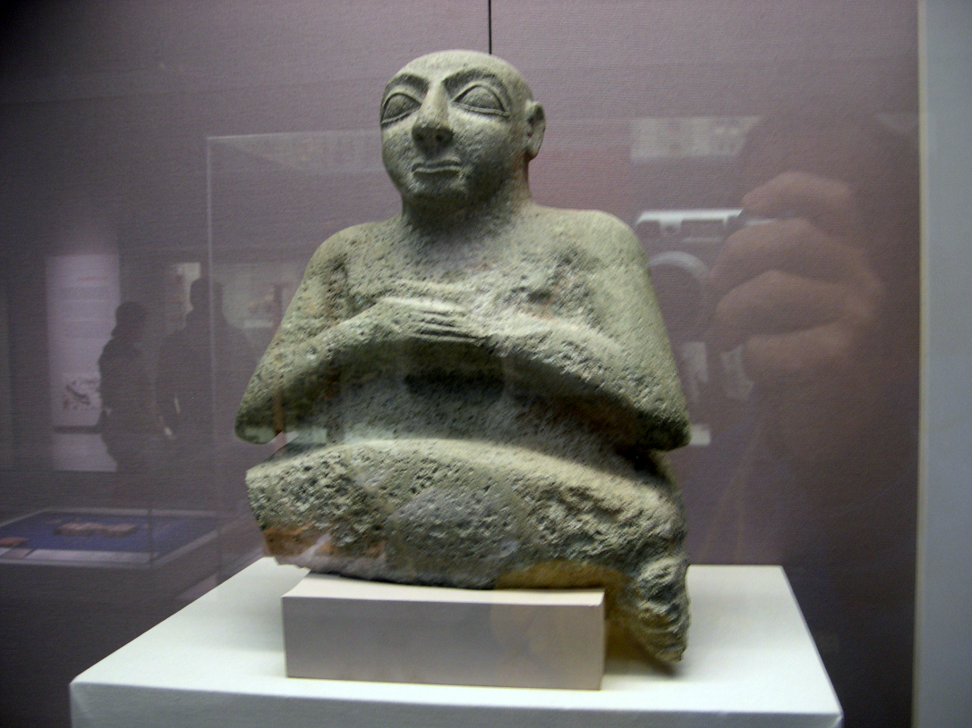
1 Chronicles 29: 11 & 12
Psalm 27 (esp. V8)

